Otzar Beit Din Document of Authorization

We, the undersigned, constitute the rabbinical court of Torah VeHa'aretz Institute established on behalf of English speakers in the Land of Israel.
Enter your first name, last name has contacted us.
Telephone no.: Enter your number
Address: Click here to enter text
S/he has also informed us that s/he owns fruit trees in his garden. We have notified him/her that the fruits have shemitah sanctity, kedushat shevi'it, and are ownerless under shemitah law. S/he, too, has declared that s/he is rendering them ownerless under Jewish law and does not view himself/herself the owner of the fruits. The abovementioned agrees that we will tend to the fruit as an agent of the beit din.
For public benefit, we see fit to request that s/he or others harvest the fruit in our name and as our agent on the public's behalf.
After the harvest s/he will place the fruit in a public area and note that they have kedushat shevi'it and are ownerless. The public will then be able to take the fruits since they are ownerless.
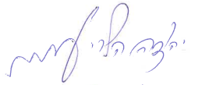 | 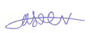 | 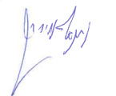
Rabbi Yehuda Amichay  Head of Institute  Torah VeHa'aretz Institute | Rabbi Moshe Bloom  English Department Director  Torah VeHa'aretz Institute | Rabbi Netanel Oyerbach  Scholar, Halachah Research Unit  Torah VeHa'aretz Institute

Fill out the form and e-mail it to Rabbi Moshe Bloom: h.moshe@toraland.org.il
or send it to him via WhatsApp at 052-8903729.

